Diseño Interfaz – DESA01 - Reserva de Aulas

Interfaz Monitor

Pantalla Login

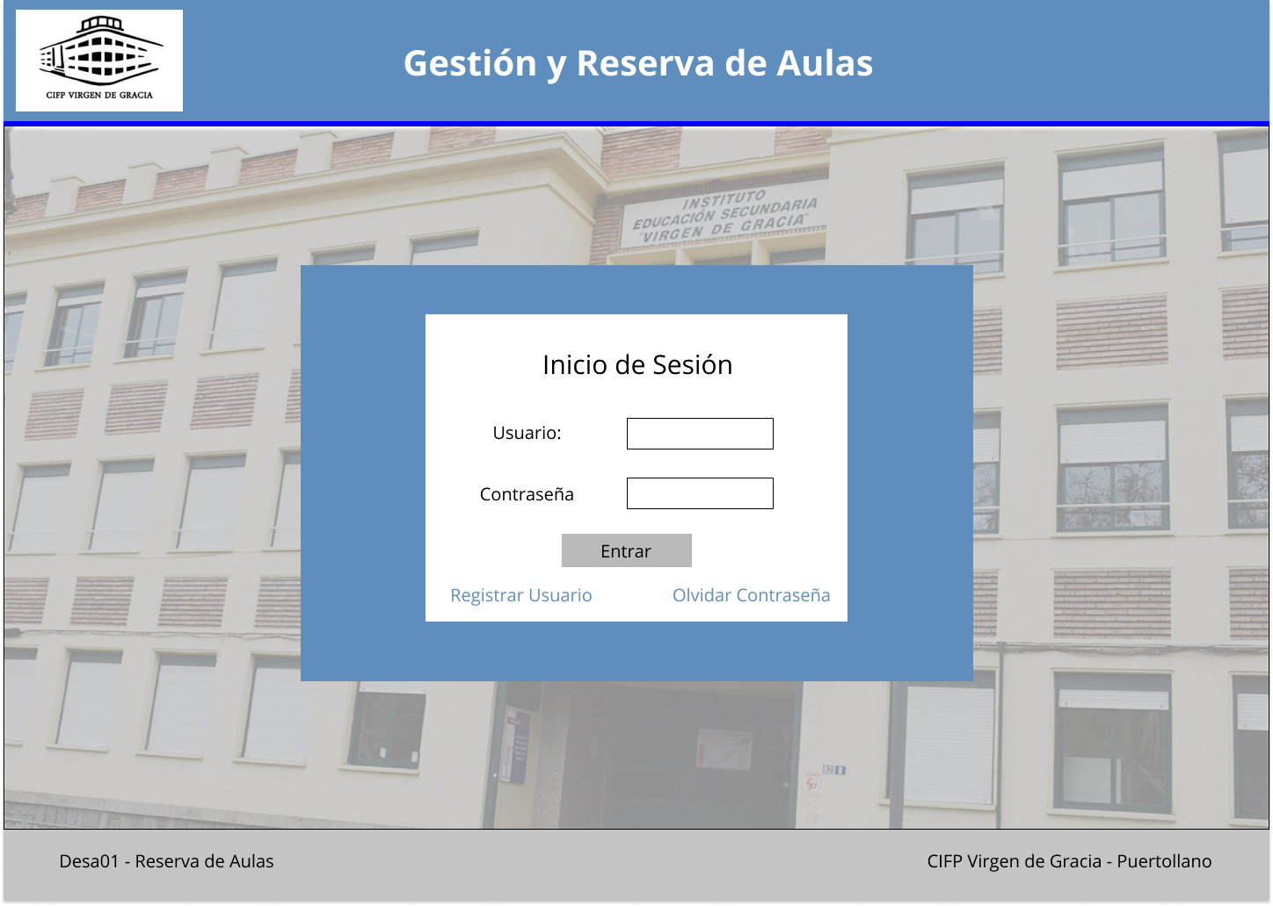

Interfaz Tablet Portrait

Interfaz Tablet Landscape

Interfaz Smartphone Portrait

Interfaz Smartphone Landscape